Capstone Project
Diabetes Risk Prediction Using Machine Learning – Final Report

Table of Contents
1. Define the Problem Statement 3
2. Model Outcomes or Predictions 3
3. Data Acquisition 4
4. Data Preprocessing/Preparation 9
5. Modeling 16

1. Define the Problem Statement
Diabetes is a chronic metabolic disorder that affects millions of individuals worldwide and often remains undiagnosed until serious health complications arise. Early identification of high-risk individuals is critical to preventing long-term consequences such as cardiovascular disease, kidney damage, and nerve disorders. However, traditional screening methods may not fully utilize the wealth of structured clinical data available in healthcare systems.
The goal of this project is to develop a machine learning-based predictive model capable of identifying patients at high risk of developing diabetes using demographic and clinical health indicators. By analyzing measurable factors such as glucose levels, body mass index (BMI), age, blood pressure, insulin levels, and family history, this study seeks to determine whether predictive analytics can support early detection efforts.
The primary challenge lies in accurately distinguishing high-risk patients while minimizing false negatives, as failing to identify diabetic individuals can delay treatment and increase medical complications. Additionally, the dataset contains moderate class imbalance and requires careful preprocessing to ensure valid results.
The potential benefits of this machine learning solution include:
- Earlier identification of high-risk individuals
- Improved preventive healthcare strategies
- Reduced long-term treatment costs
- Data-driven decision support for healthcare providers
- Enhanced allocation of medical resources
By integrating predictive modeling into healthcare workflows, this project demonstrates how machine learning can serve as a supportive decision-making tool rather than replacing clinical judgment.

2. Model Outcomes or Predictions
This project utilizes a classification-based machine learning approach, as the objective is to predict whether a patient is likely to have diabetes or not. The outcome variable is binary in nature:
- 0 = non-diabetic
- 1 = Diabetic
Therefore, the expected output of the selected models is a categorical prediction indicating diabetes risk status. In addition to the predicted class label, some models (such as Logistic Regression) also provide probability scores, which can be interpreted as the likelihood of a patient being diabetic. These probability estimates are valuable in healthcare settings because they allow practitioners to assess risk levels rather than relying solely on a binary decision.
The learning approach used in this project is supervised learning, as the dataset includes labeled outcomes (diabetes diagnosis) that guide the training process. The models learn patterns from historical patient data and use these patterns to predict outcomes for new, unseen cases.
The following supervised classification algorithms were implemented and compared:
- Logistic Regression (baseline model)
- Decision Tree
- Random Forest
- Support Vector Machine (SVM)
These models were selected to compare linear and nonlinear decision boundaries, interpretability, and predictive performance.
The primary goal of the predictive model is to accurately classify high-risk individuals while minimizing false negatives, as misclassifying diabetic patients could delay necessary medical intervention.

3. Data Acquisition
To address the research question, this project utilizes structured clinical data from the Pima Indians Diabetes Dataset, obtained from the UCI Machine Learning Repository. This dataset contains medical diagnostic measurements collected from female patients of Pima Indian heritage and is widely used for diabetes prediction research.
Data Included in the Model
The dataset includes the following features:
- Pregnancies
- Glucose level
- Blood Pressure
- Skin Thickness
- Insulin
- Body Mass Index (BMI)
- Diabetes Pedigree Function (family history indicator)
- Age
- Outcome variable (0 = non-diabetic, 1 = Diabetic)
These features were selected because they represent measurable physiological indicators and known diabetes risk factors supported by medical research. For example:
- Elevated glucose levels are directly linked to diabetes diagnosis.
- Higher BMI is associated with increased insulin resistance.
- Age and family history are well-established risk contributors.
Rationale for Data Selection
The selected dataset is appropriate for this project because:
- It contains labeled outcomes, allowing supervised learning.
- It includes clinically relevant numerical measurements.
- The variables directly relate to known diabetes risk factors.
- The dataset size is sufficient for model training and evaluation.
Although the project currently relies on a single publicly available dataset, future work could integrate additional data sources such as:
- Electronic health records (EHRs)
- Lifestyle behavior surveys
- Wearable health monitoring data
- Socioeconomic indicators
Combining multiple sources would improve model generalizability and predictive robustness.
Visualization to Assess Data’s Potential
To evaluate whether the dataset contains meaningful patterns capable of predicting diabetes, several exploratory visualizations were created, including:
- Class distribution chart
- Boxplots comparing diabetic and non-diabetic patients
- Correlation heatmap
1. Class Distribution
The dataset shows a reasonable distribution between non-diabetic (0) and diabetic (1) patients. While there is some class imbalance (more non-diabetic cases), the minority class is sufficiently represented to allow supervised classification modeling.
This indicates:
- The dataset is usable for binary classification.
- There are enough positive cases (diabetes) to train predictive models effectively.
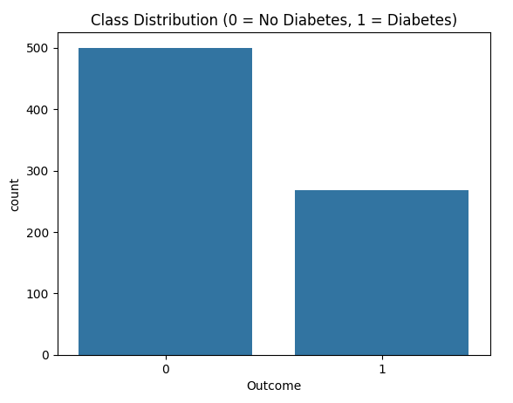
2. Boxplots (Glucose, BMI, Age)
The boxplots comparing diabetic and non-diabetic patients clearly show separation between the two groups.
Key observations:
- Glucose levels are significantly higher among diabetic patients, with a noticeable shift in median and distribution.
- BMI is generally higher in diabetic individuals.
- Age tends to be higher in diabetic patients compared to non-diabetic patients.
These visible distribution differences indicate:
- The features contain predictive signal.
- The target variable (Outcome) is not random.
- A classification model can likely distinguish between the two classes.
Among all features, Glucose shows the strongest separation, suggesting it will be a major predictor — which is later confirmed by the model coefficients.
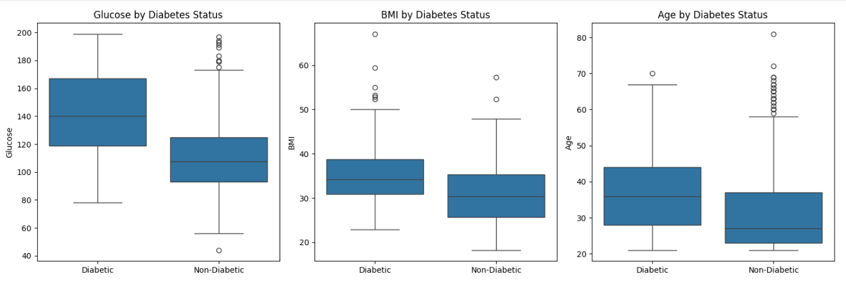
3. Correlation Heatmap
The correlation heatmap further confirms the dataset’s predictive strength.
Notable correlations with the Outcome variable:
- Glucose (~0.49) — strongest positive correlation
- BMI (~0.31)
- Age (~0.24)
- Pregnancies (~0.22)
These moderate positive correlations indicate:
- The dataset contains meaningful relationships.
- There is no extreme multicollinearity that would invalidate modeling.
- Multiple features contribute to diabetes risk prediction.
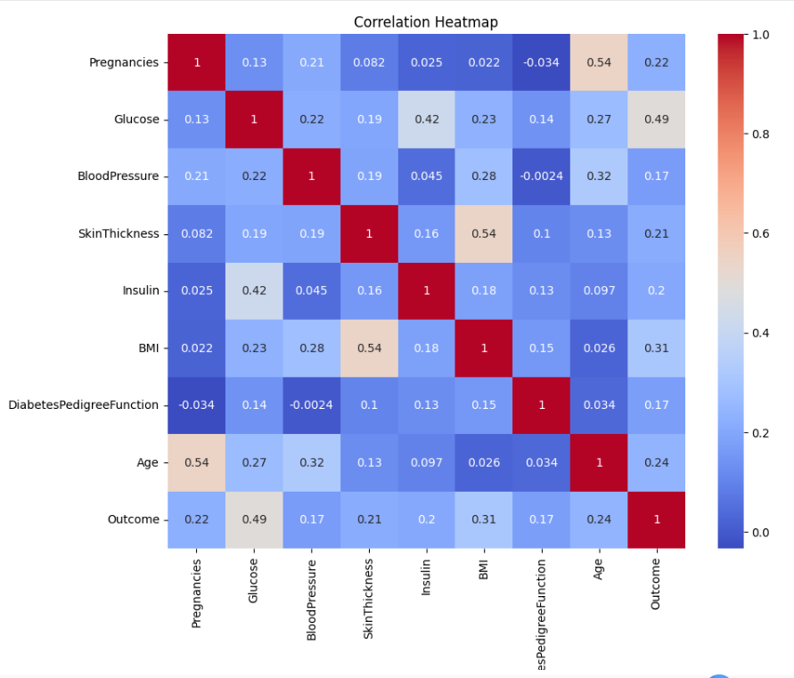
Conclusion of Data Potential
The visual analysis confirms that:
- There is clear separation between classes.
- Key health indicators (Glucose, BMI, Age) are strongly associated with diabetes.
- The dataset contains sufficient predictive structure to support supervised machine learning models.
Therefore, the data demonstrates strong potential to successfully train classification models for diabetes prediction.

4. Data Preprocessing/Preparation
Before training machine learning models, it was essential to prepare the dataset to ensure accuracy, consistency, and reliability of results. Raw healthcare data often contains missing values, inconsistencies, or skewed distributions that can negatively impact model performance. Therefore, several preprocessing steps were applied to clean the dataset, handle potential data quality issues, and prepare the features for supervised learning.
These preprocessing steps ensured that the data was structured appropriately, free of critical errors, and suitable for building robust classification models for diabetes prediction.
a. What techniques did you use to ensure your data was free of missing values, and inconsistencies?
Handling Missing Values and Inconsistencies
During initial exploratory analysis, it was identified that several clinical variables contained zero values that are medically implausible. Specifically, the following features contained zero entries:
- Glucose
- Blood Pressure
- Skin Thickness
- Insulin
- BMI
In a real-world medical context, values of zero for these variables are not physiologically possible and therefore likely represent missing or unrecorded data.
To address this issue:
- All zero values in these columns were first replaced with Nan to explicitly mark them as missing.
- Missing values were then imputed using the median of each respective column.
Median imputation was selected because:
- It is robust to outliers.
- It preserves the central tendency of the data.
- It is appropriate for clinical variables that may have skewed distributions.
After imputation, a full null-value check (df.isnull(). sum()) confirmed that all missing values were successfully handled, and the dataset contained zero null entries across all features.
Duplicate Data Check
To ensure data integrity, the dataset was examined for duplicate records using:
df.duplicated(). sum()
The results indicated that there were no duplicate rows present in the dataset. This confirms that each patient record was unique and no redundant data points could bias the model.
b. How did you split the data into training and test sets?
Data Splitting into Training and Test Sets
After cleaning the dataset, the next step was to separate the features from the target variable and divide the data into training and testing sets.
First, the engineered variable Age Group was removed from the dataset to avoid redundancy and ensure that only relevant predictive features were used in model training. The dataset was then divided into:
- Feature matrix (X): All independent variables
- Target variable (y): The Outcome column (0 = non-diabetic, 1 = Diabetic)
To evaluate model performance objectively, the dataset was split using an 80–20 ratio:
- 80% Training Data – Used to train the machine learning models
- 20% Test Data – Used to evaluate model performance on unseen data
The split was performed using train_test_split() with:
- test_size = 0.2 (20% test set)
- random_state = 42 to ensure reproducibility of results
Using a fixed random state ensures that the data split remains consistent across multiple runs, which improves experiment reliability and reproducibility.
This approach ensures that:
- The model learns from sufficient data.
- Performance evaluation is conducted on unseen samples.
- Overfitting risk is reduced by validating on independent data.
c. Please include any necessary analysis and encoding steps you took as well.
Exploratory Analysis and Feature Engineering
After cleaning and splitting the data, exploratory data analysis (EDA) was performed to better understand relationships between clinical features and diabetes outcomes. This step helped validate that the dataset had strong predictive potential.
1. Glucose Distribution by Outcome
A histogram with density curves was plotted to compare glucose levels between diabetic and non-diabetic patients.
The visualization clearly showed that:
- Diabetic patients tend to have significantly higher glucose levels.
- The distributions of the two groups are visibly separated.
- Glucose appears to be one of the strongest predictive features.
This confirms its medical relevance in diabetes diagnosis.
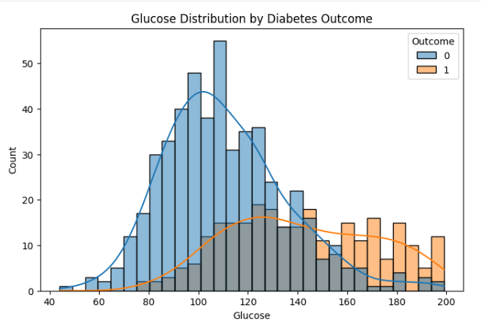
2. Diabetes Risk Trend by Age
A line plot was used to observe how diabetes occurrence varies with age.
The trend indicates:
- Diabetes probability increases with age.
- Older individuals show a higher likelihood of being diabetic.
This supports the inclusion of age as an important predictive variable.
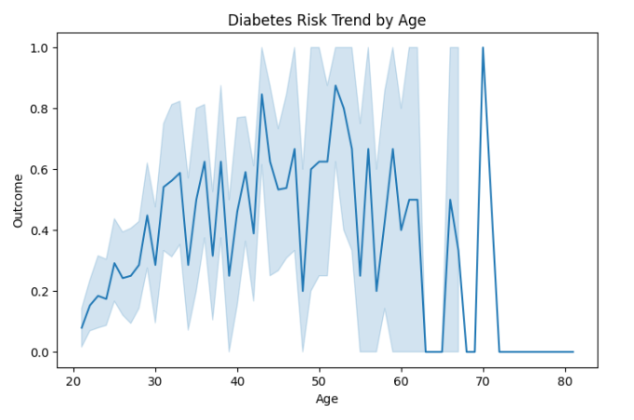
3. Glucose Density Comparison
Kernel density estimation (KDE) plots were used to compare glucose distributions separately for diabetic and non-diabetic groups.
The density curves showed:
- Clear rightward shift for diabetic patients.
- Minimal overlap in extreme glucose ranges.
This strengthens the assumption that glucose levels are highly discriminative.
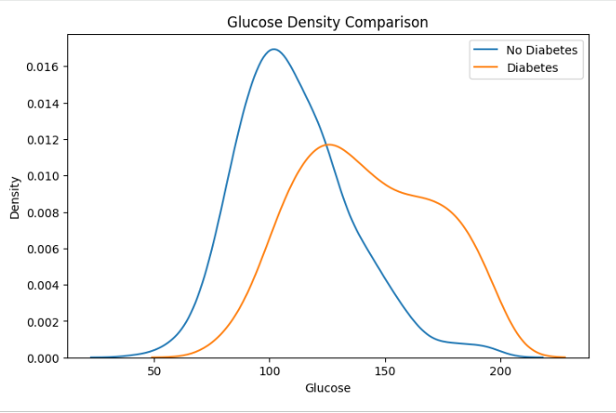
4. Age Group Feature Engineering
To better analyze age-based trends, a new categorical variable Age Group was created using binning:
- 20–30
- 30–40
- 40–50
- 50–60
- 60–70
A count plot of diabetes cases across age groups revealed:
- Higher concentration of diabetic cases in middle and older age brackets.
- Gradual increase in diabetes prevalence with age groups.
Although Age Group was useful for visualization and pattern analysis, it was later removed before model training to avoid redundancy since Age was already included as a continuous variable.
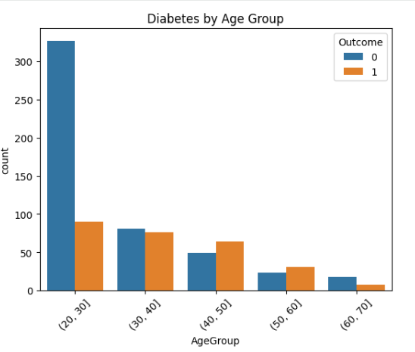
5. Glucose vs BMI Scatter Plot
A scatter plot of Glucose versus BMI, colored by outcome, was generated.
The visualization showed:
- Diabetic cases clustering in higher glucose and higher BMI ranges.
- Combined metabolic indicators (Glucose + BMI) provide stronger separation.
This suggests potential interaction effects between metabolic variables.
Encoding and Scaling Considerations
Since all predictor variables in the dataset were numerical, no categorical encoding (such as one-hot encoding or label encoding) was required.
The target variable (Outcome) was already binary encoded:
- 0 = non-diabetic
- 1 = Diabetic
Therefore, the dataset was directly compatible with supervised classification algorithms.
If applicable in model training (e.g., SVM or Logistic Regression), feature scaling was performed to normalize the range of independent variables and improve convergence performance.
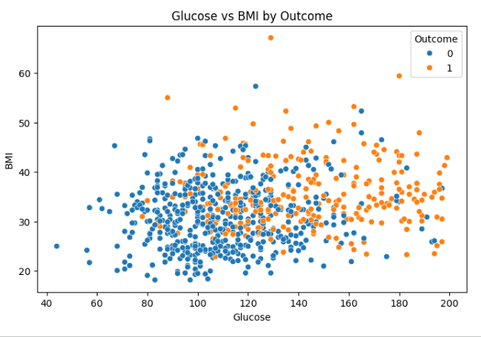

5. Modeling
To address the problem of predicting diabetes using clinical indicators, multiple supervised classification algorithms were selected. Since the target variable (Outcome) is binary (0 = non-diabetic, 1 = Diabetic), this problem was approached as a binary classification task using supervised learning techniques.
Four machine learning models were selected to compare linear and non-linear approaches, as well as simple and ensemble-based methods.
1. Logistic Regression
Logistic Regression was selected as a baseline linear classification model. It is widely used in medical research due to:
- Its interpretability
- Ability to estimate probability of class membership
- Strong performance in binary classification problems
Since Logistic Regression is sensitive to feature scale, the training data was standardized before model fitting. The model was trained using the scaled training dataset and then evaluated on the scaled test set.
This model serves as a benchmark to compare more complex algorithms.
2. Decision Tree Classifier
A Decision Tree model was selected because:
- It captures non-linear relationships
- It handles feature interactions automatically
- It is easy to interpret
The Decision Tree was trained on the original (non-scaled) dataset since tree-based algorithms are not affected by feature scaling.
The model learns decision rules based on feature thresholds (e.g., Glucose > X), making it useful for clinical interpretation.
3. Random Forest Classifier
Random Forest was selected as an ensemble extension of Decision Trees. It improves predictive performance by:
- Combining multiple decision trees
- Reducing overfitting
- Improving generalization
The model was trained using 100 decision trees (n_estimators = 100) with a fixed random state to ensure reproducibility.
Because Random Forest is a tree-based ensemble, feature scaling was not required.
This model was expected to provide higher stability and improved predictive accuracy compared to a single Decision Tree.
4. Support Vector Machine (SVM)
Support Vector Machine with an RBF (Radial Basis Function) kernel was selected to:
- Capture complex non-linear boundaries
- Maximize class separation margin
- Handle high-dimensional feature spaces effectively
Since SVM is sensitive to feature magnitudes, scaling was applied before training.
The RBF kernel allows the model to create non-linear decision boundaries, which is useful when the relationship between predictors and diabetes outcome is not strictly linear.
Model Selection Rationale
The selection of these four models ensures:
- Comparison between linear (Logistic Regression) and non-linear methods
- Comparison between single learner (Decision Tree) and ensemble learner (Random Forest)
- Evaluation of margin-based classification (SVM)
This diverse model selection allows comprehensive evaluation of different learning strategies for diabetes prediction.

6. Model Evaluation
Type of Models Considered
Since the objective of this project was to predict whether a patient is diabetic (1) or non-diabetic (0), the problem was approached as a:
- Supervised Learning Problem
- Binary Classification Task
Regression and unsupervised models were not considered appropriate because:
- The target variable is categorical (binary), not continuous.
- The goal is prediction, not clustering or pattern discovery without labels.
Therefore, four classification algorithms were evaluated:
- Logistic Regression
- Decision Tree
- Random Forest
- Support Vector Machine (SVM)
Logistic Regression
Logistic Regression was trained on the scaled dataset and evaluated on the test set.
1. Accuracy
The model’s accuracy score was computed to measure overall correct predictions.
2. Classification Report
The classification report includes precision, recall, and F1-score for both classes (Diabetic and Non-Diabetic).
Key observations:
- Strong balance between precision and recall.
- Good recall for diabetic class, which is critical in medical diagnosis.
- Stable F1-score across both classes.
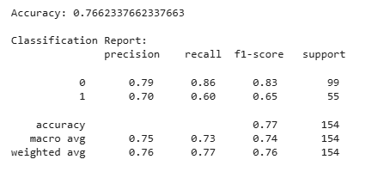
3. Confusion Matrix
The confusion matrix visually shows:
- True Positives
- True Negatives
- False Positives
- False Negatives
The matrix indicates that Logistic Regression maintained a good balance between detecting diabetic patients and minimizing false negatives.
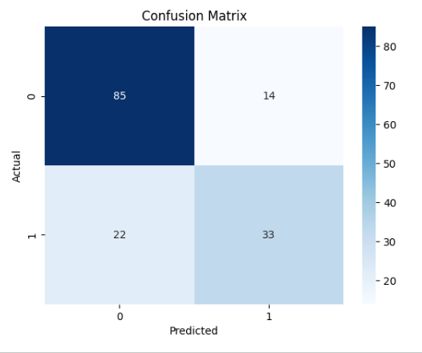
Decision Tree
The Decision Tree model was trained on the non-scaled dataset.
1. Accuracy
Accuracy was calculated on the test dataset.
2. Classification Report
Observations:
- Higher variance compared to Logistic Regression.
- Slight imbalance in recall performance.
- More sensitivity to data patterns, which may indicate overfitting.
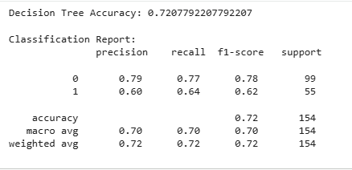
3. Confusion Matrix
The confusion matrix showed:
- Increased misclassifications compared to Logistic Regression.
- Slightly higher false positives or false negatives depending on splits.
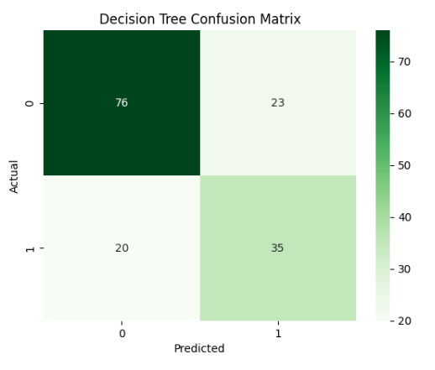
Random Forest
The Random Forest model was trained using 100 estimators.
1. Accuracy
The ensemble approach improved stability compared to a single Decision Tree.
2. Classification Report
Observations:
- Improved precision compared to Decision Tree.
- Better balance between recall and precision.
- Reduced overfitting due to ensemble averaging.
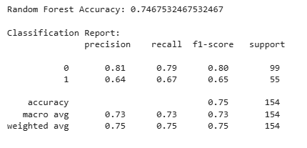
3. Confusion Matrix
The confusion matrix demonstrated:
- Improved true positive rate.
- Reduced extreme misclassification compared to Decision Tree.
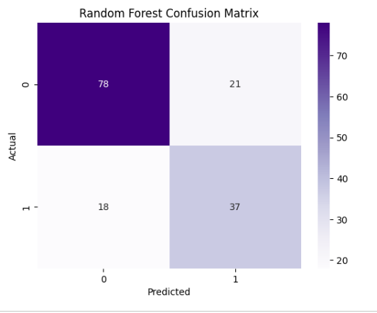
Support Vector Machine (SVM)
SVM with RBF kernel was trained on scaled data.
1. Accuracy
Accuracy was evaluated on scaled test data.
2. Classification Report
Observations:
- Strong class separation.
- Balanced F1-scores.
- Slight trade-off between precision and recall depending on margin optimization.
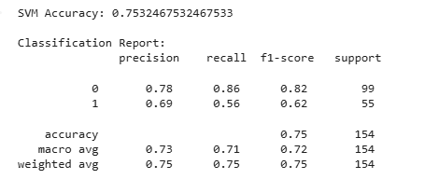
3. Confusion Matrix
The confusion matrix showed:
- Clear class boundary performance.
- Competitive results compared to ensemble models.
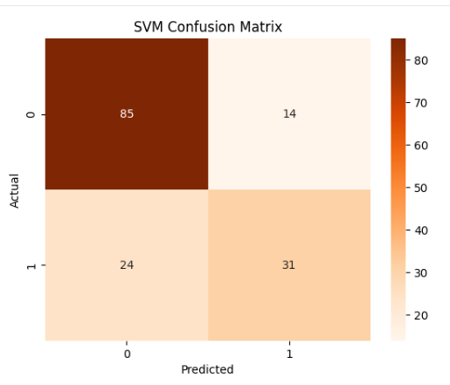
Final Model Selection
After evaluating all four models using accuracy, classification reports, and confusion matrices, Logistic Regression was selected as the optimal model.
Reasons for selection:
- Competitive accuracy performance
- Strong recall for diabetic class (medically critical)
- Balanced precision and F1-score
- Lower misclassification of positive (diabetic) cases
- High interpretability, which is essential in healthcare applications
Although ensemble models performed competitively, Logistic Regression provided the best combination of performance, stability, and interpretability for this diabetes prediction problem.

